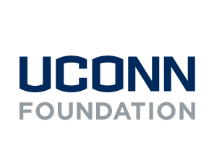
How to Become a Champion

Step by step instructions through the Community Funded Platform to
sign up and become a champion.

What is a UConn Gives Champion?

Someone who:
- Truly bleeds blue with a strong passion for UConn
- Has a strong network to engage (think: people who have an active social media presence, are/were highly involved on campus, frequently attend alumni events, etc.)

What does a UConn Gives champion do?

- Reach out to their network on social media, email, phone, or whatever medium they are most comfortable with
- Prior to UConn Gives: Send save–the–date messages and posts, share why they are choosing to donate, and encourage others to join them
- During UConn Gives: Participate in social media challenges
- Share links to giving pages and encourage people to give on social media
- Send emails to their network encouraging people to give
- Call/text/send a carrier pigeon (whatever their preferred method!)

Become a Champion:

Step 1:
- Find the story you intend on being a champion for. In this example we will use The Fund for UConn.
- Click “Get Personal Share Link” in the Become a Champion box on the right-hand margin of the page.
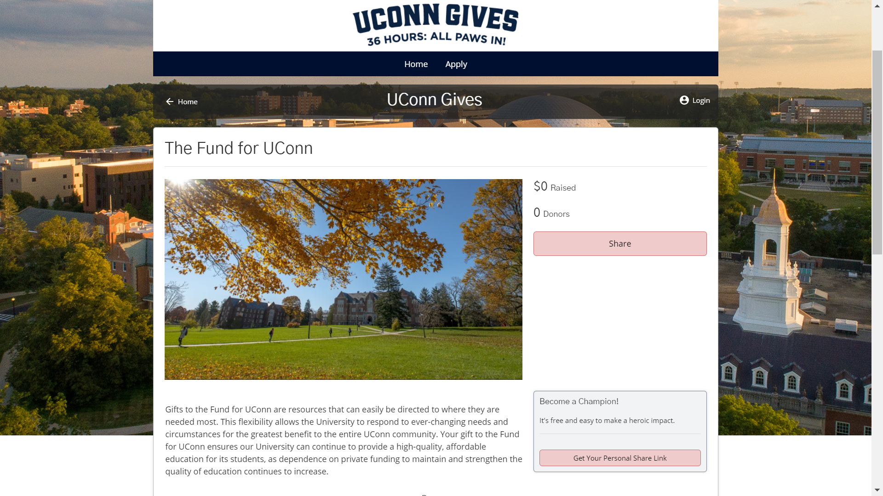
Step 2: Fill in your email address for the confirmation link. If you already have an account from previous years you are able to log in from here.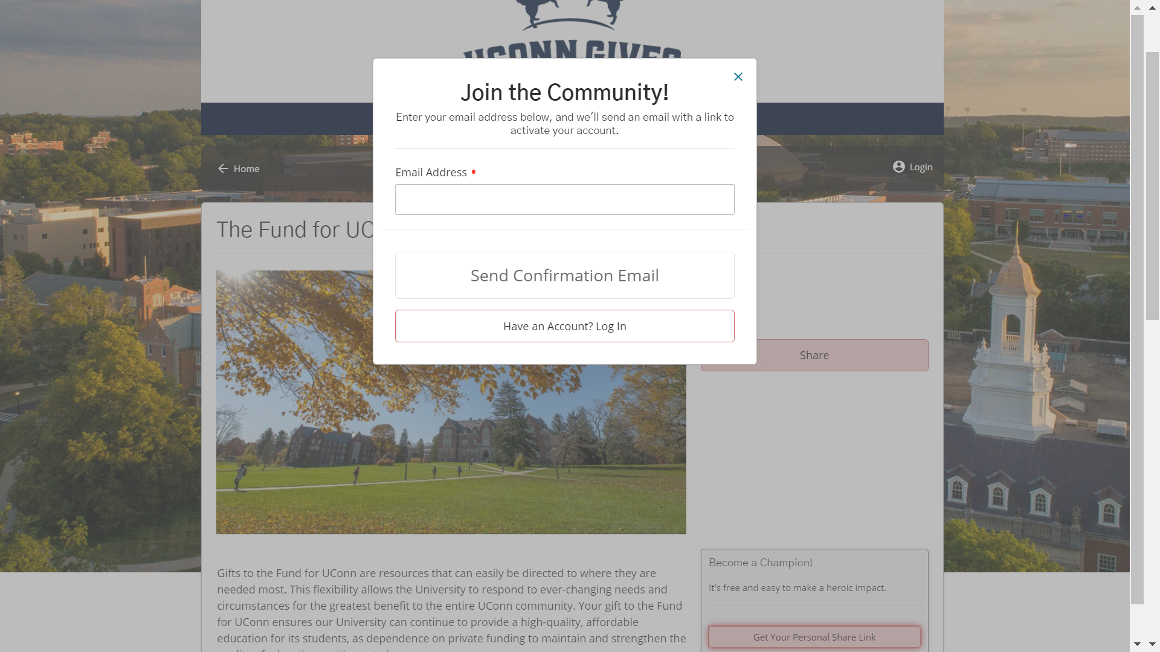

Step 3: Navigate to the email you put in
- Look for an email from info@communityfunded.com. If this email is not in your inbox within 5 minutes please refresh the page and check you spam folder
- Emails from this address have frequently been lost in Spam or Promotion Tab on Gmail.
- Hit “Lets do this!” to be rerouted to the giving page.
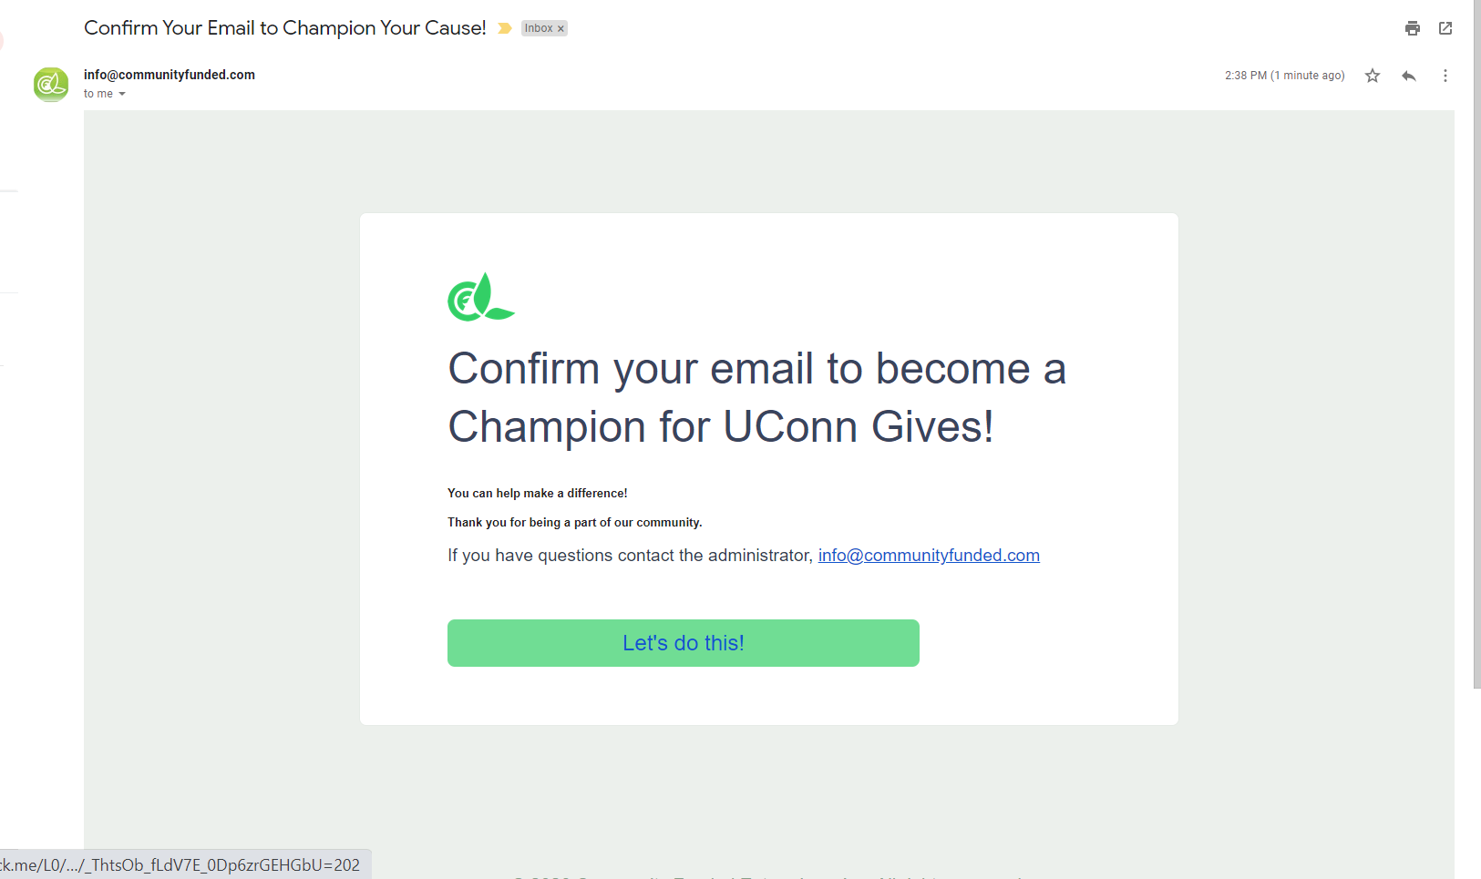
Step 4: Fill in Contact Sheet
- Fill in this sheet with the neccesary information.
  - Fields with a red dot are mandatory. If you leave a section blank you will not be able to submit the information
- Write your password down as you will be able to use this account in future years.
- Hit “confirm” when finished
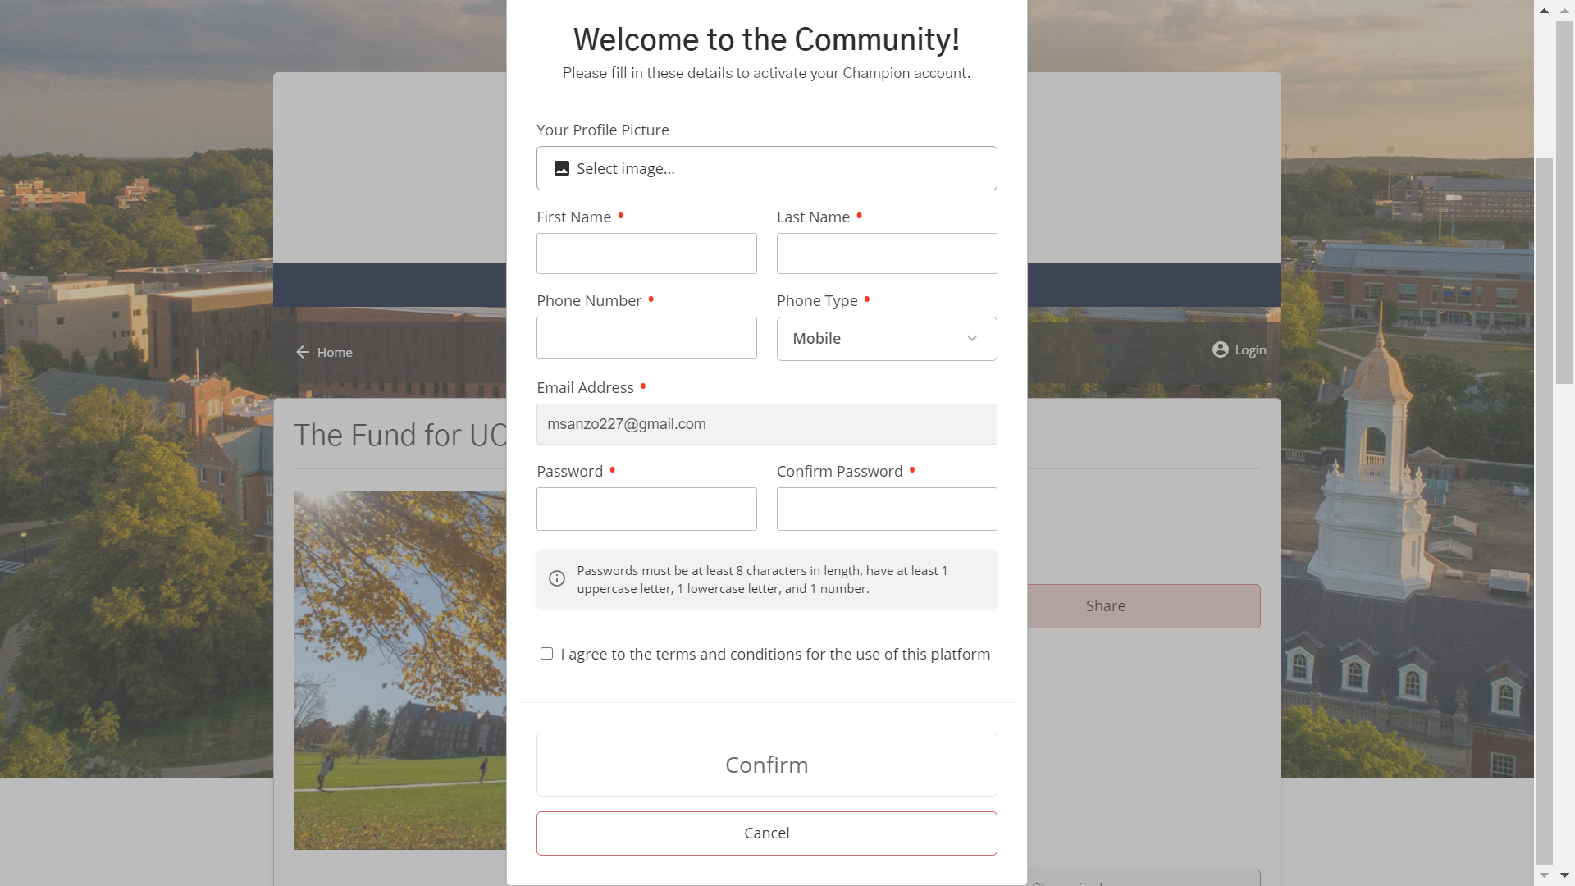

Step 5: Champion This Story!
- Click on “Champion This Story” of the one you are interested in.
- You will see a gallery of stories under the “Find Stories” section. If you would like to champion more than one, they will be listed here.
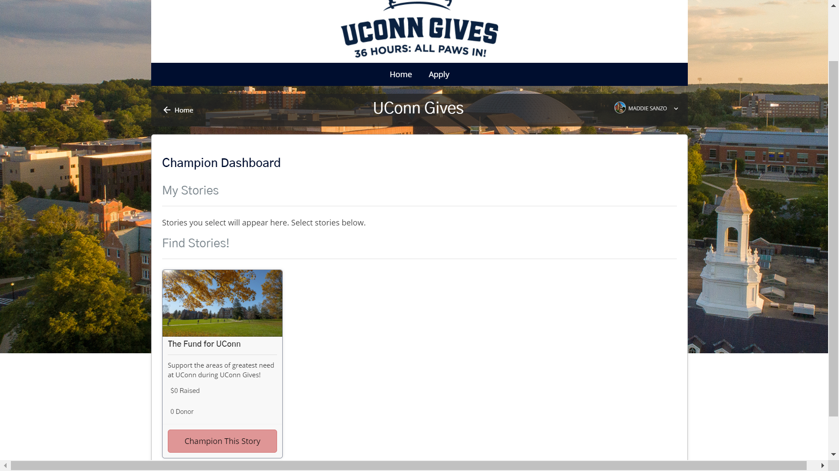

Step 6: Fill in Champion Information
- Your personal message will be displayed on your Champion Dashboard for donors to see. This is where you can state the importance of giving to your cause, why you care, the mission, etc.
- Your goal can be one of the suggested or a custom number
- Hit continue when finished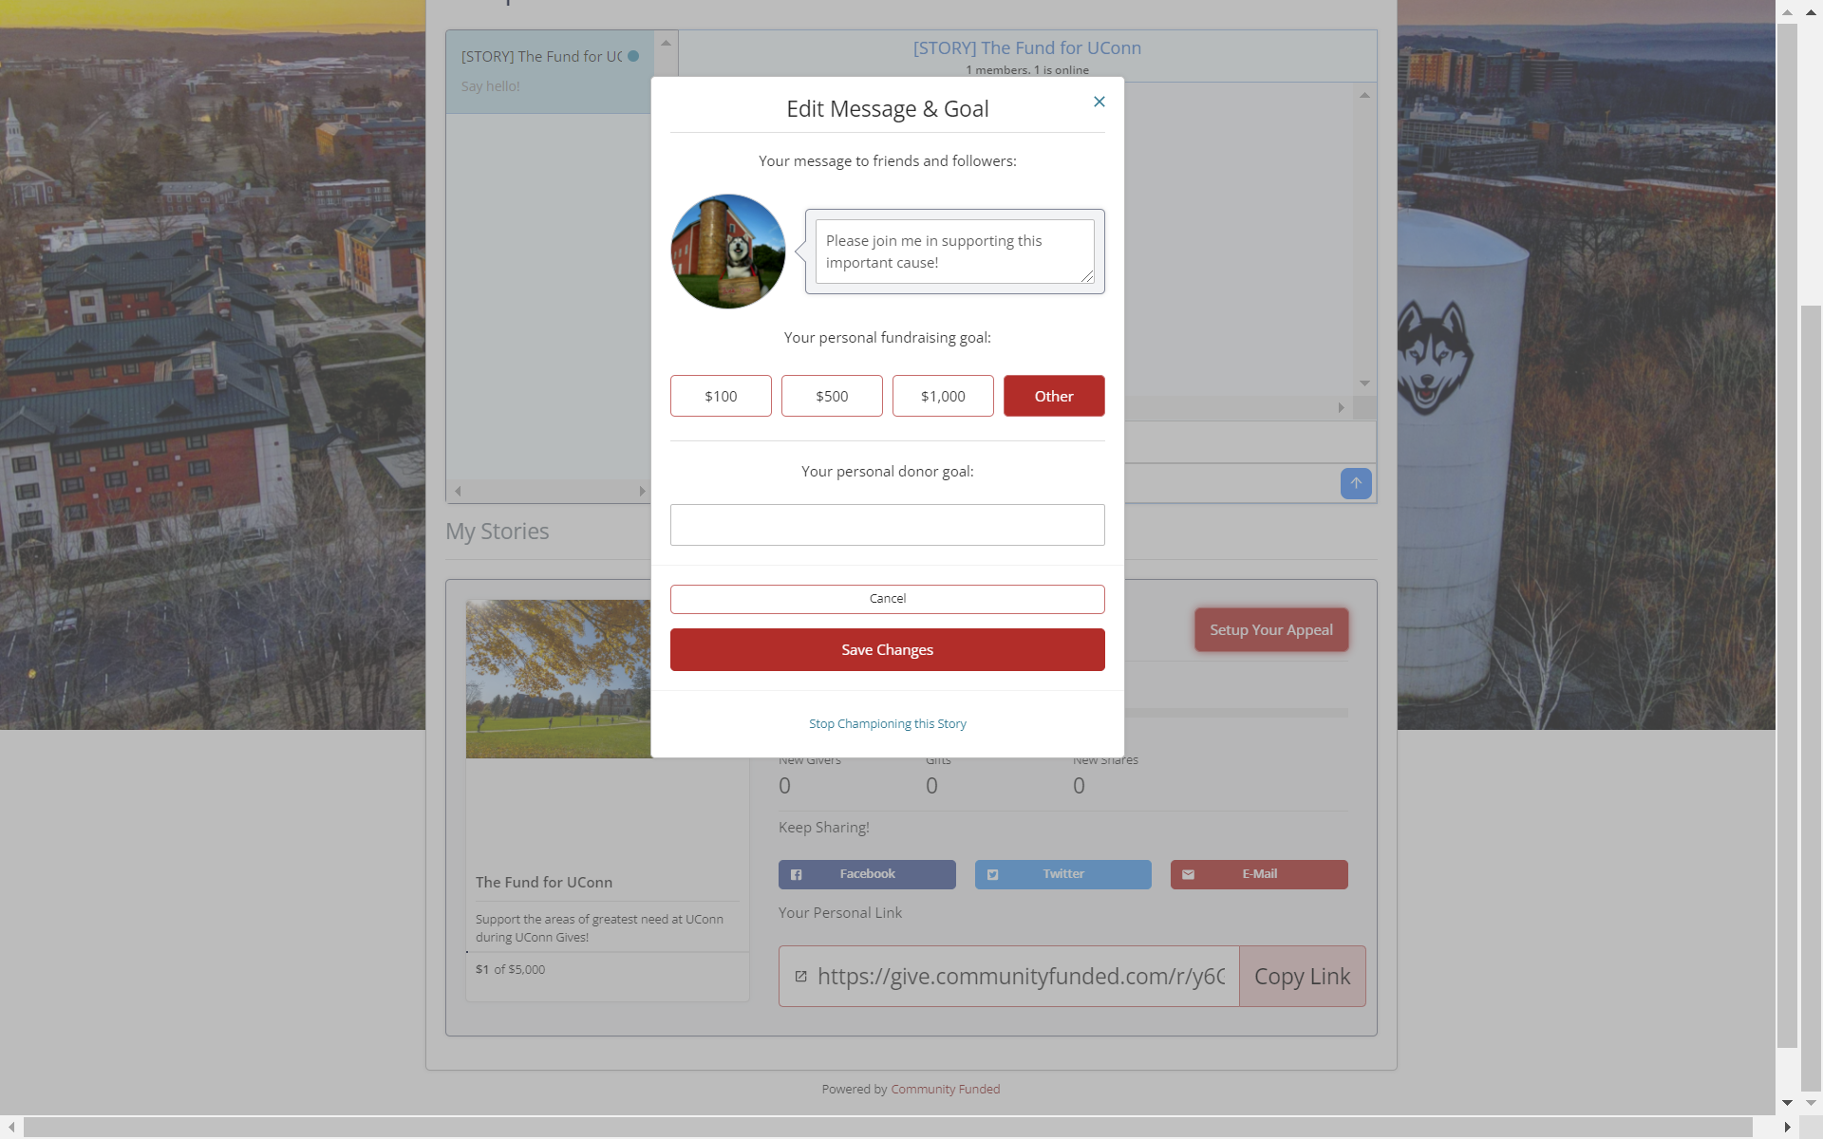

Step 7: Setting up Chat Communication
- Click “Setup Chat Communication”
- Plug in your name
- Chat with other champions of your story
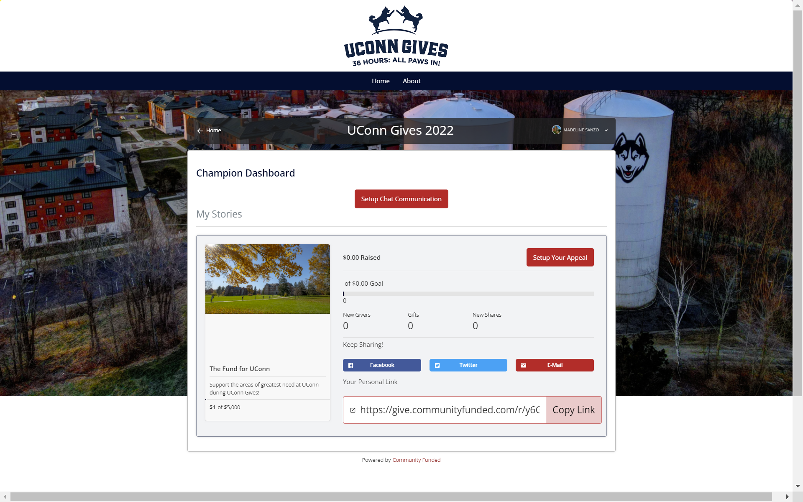
Step 8: Get familiar with your dashboard
- “Setup Your Appeal” – gives you the chance to edit your personal message and donor goal from step 6
- Click on the Facebook, Twitter or Email buttons to share quickly to those sites
- Copy Link to your Dashboard to share with friends and family!
- Come back often to check the stats for your cause and chat with others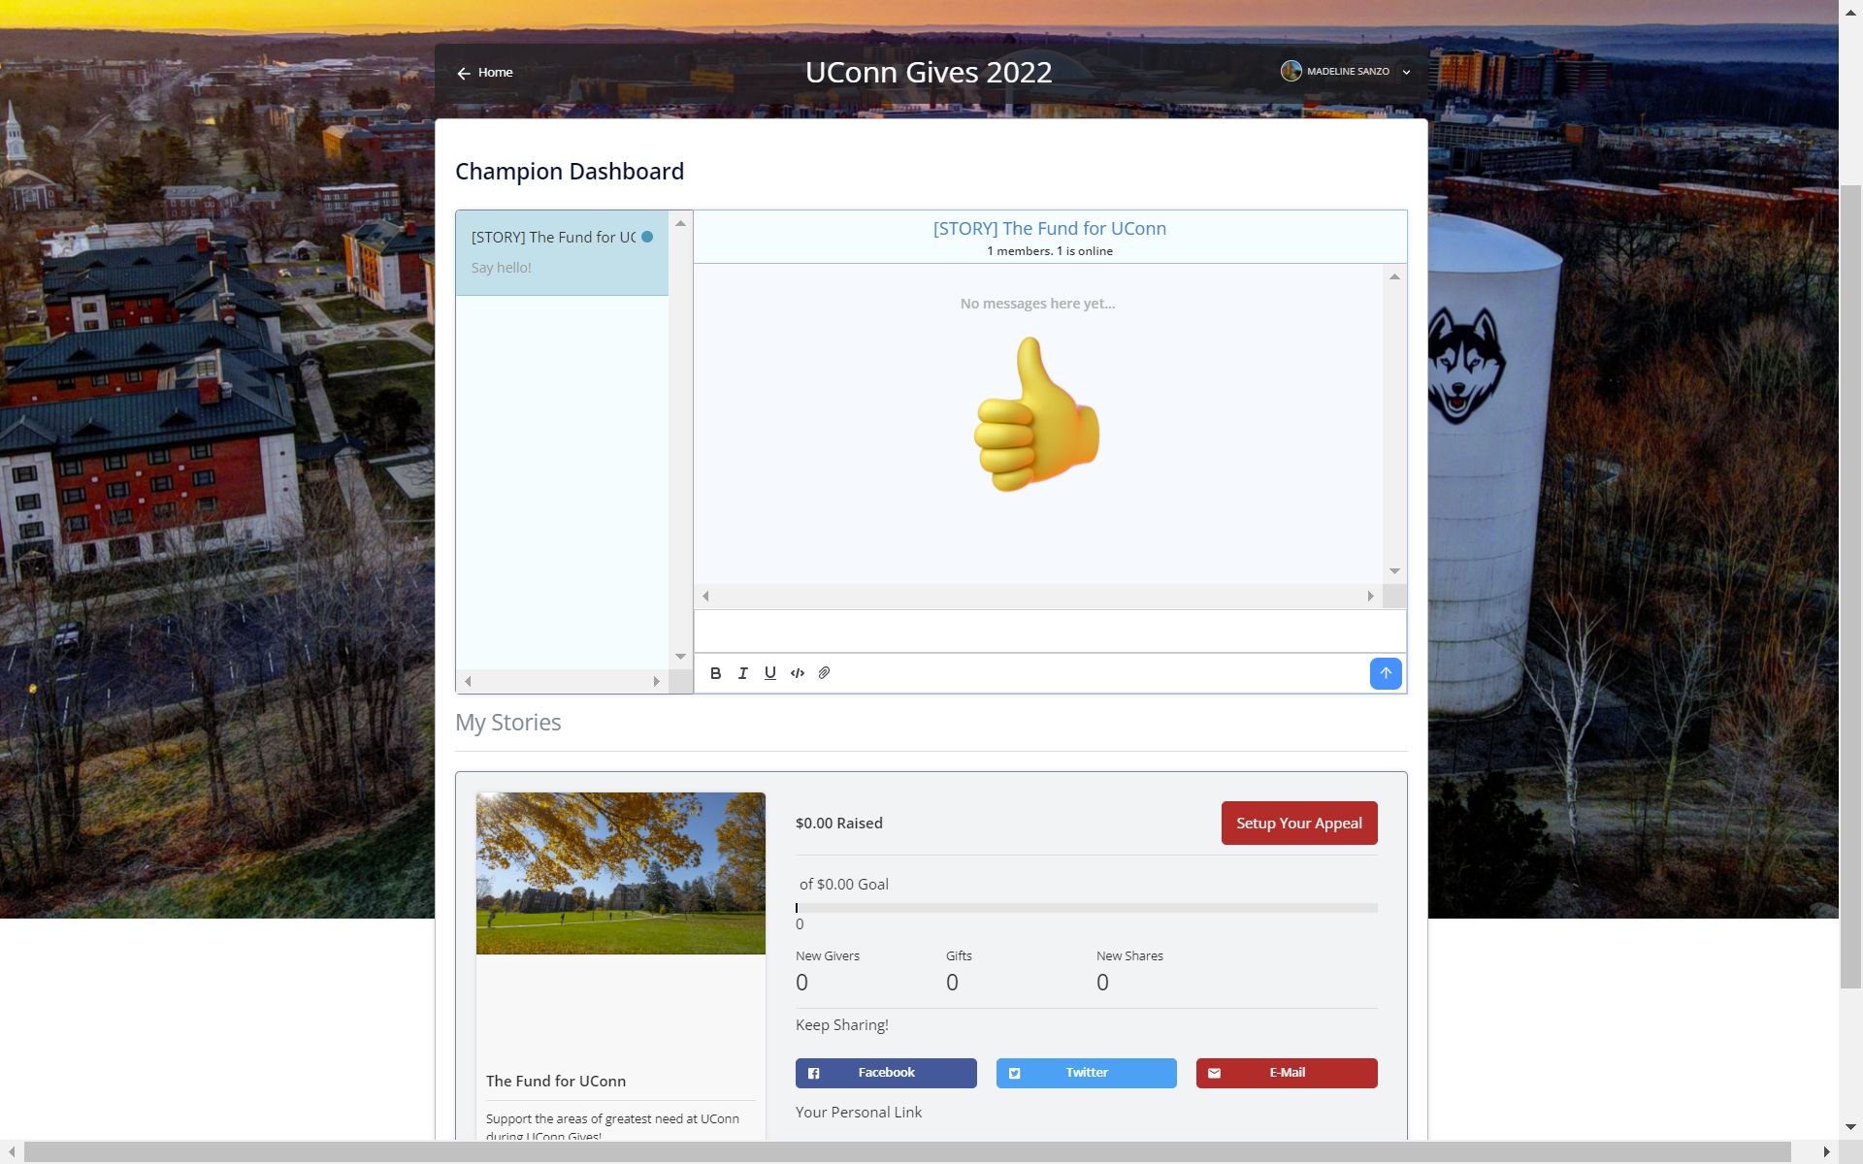
Step 9: Need to edit?
- Click “Edit Profile” in the dropdown menu
- You can change your profile photo and other necessary contact information.
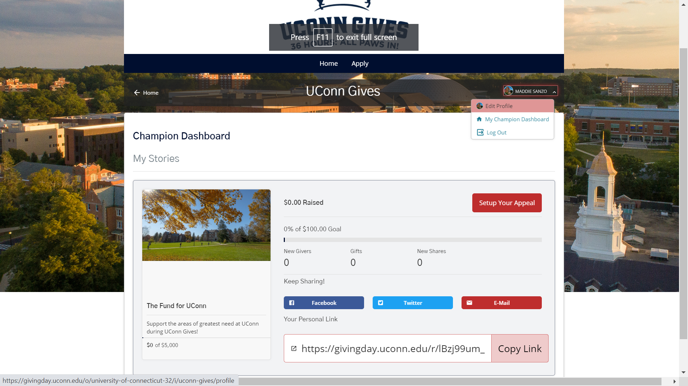

Questions on becoming a Champion?
Contact Madeline Sanzo at msanzo@foundation.uconn.edu with any champion related questions.

Having technical issues with Community Funded?
Contact Amanda Bradley at abradley@foundation.uconn.edu

